**1.2 Exercises**

Harlan Wittlieff

Data Science, Bellevue University

DSC 640: Data Presentation & Visualization

Catie Williams

March 23, 2022

# PowerBI - Bar Chart

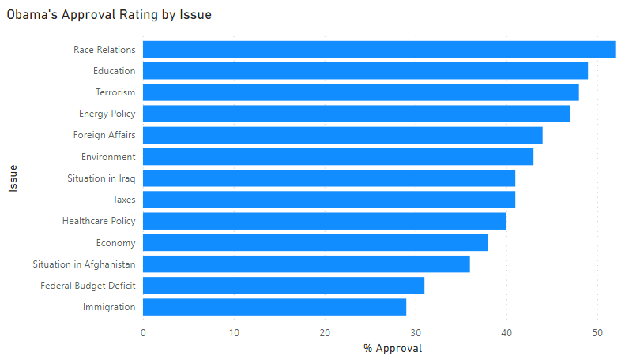

# PowerBI – Stacked Bar Chart

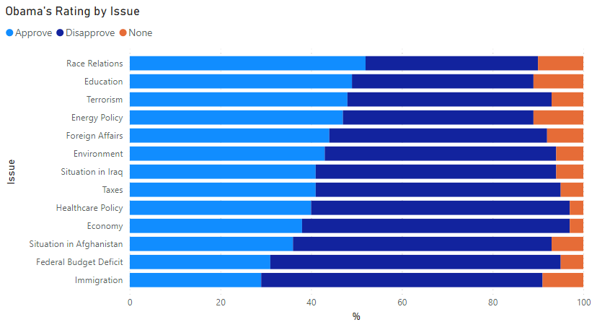

# PowerBI – Pie Chart

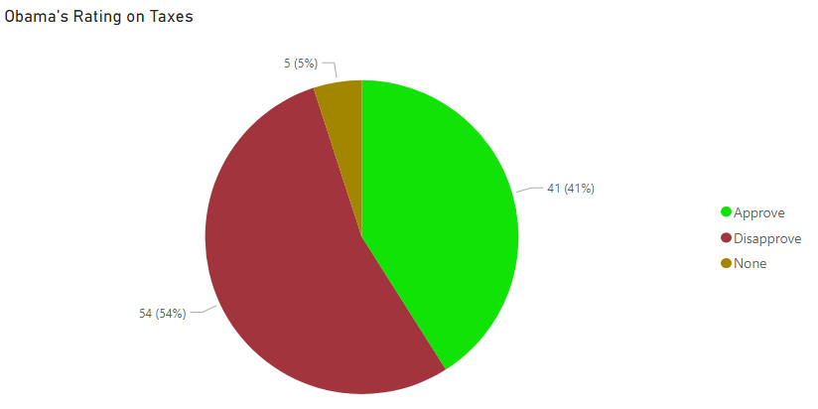

# PowerBI – Donut Chart

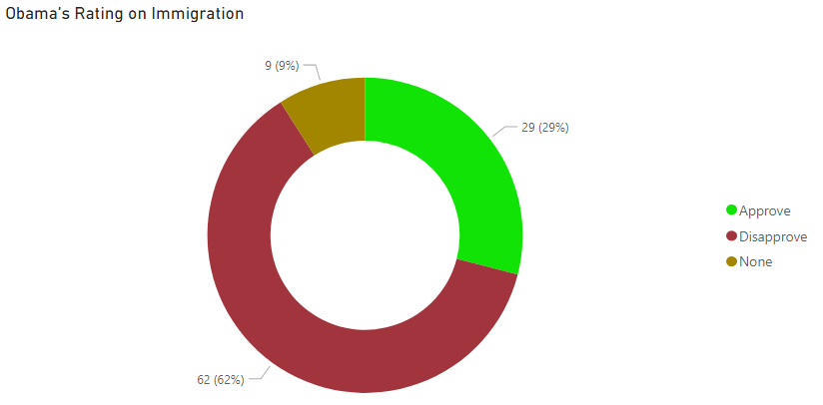

# R - Bar Chart

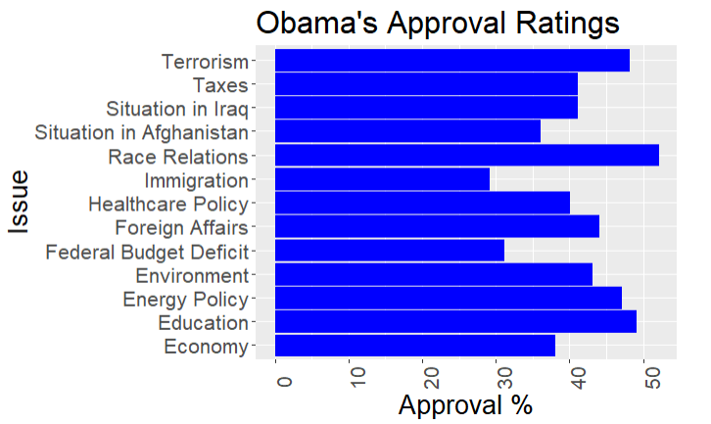

# R – Stacked Bar Chart

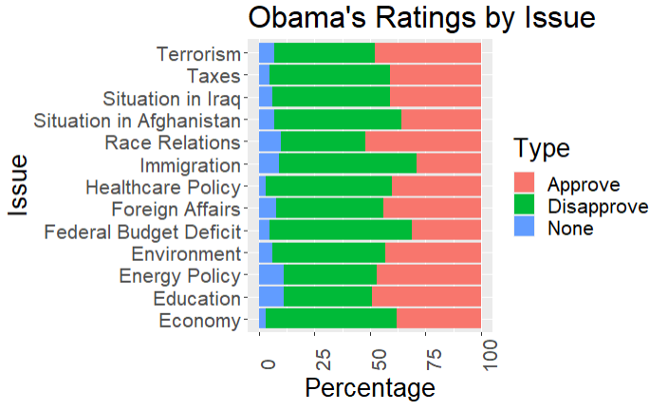

# R – Pie Chart

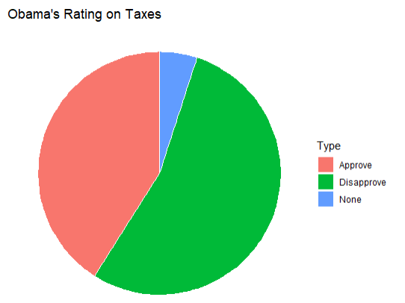

# R – Donut Chart

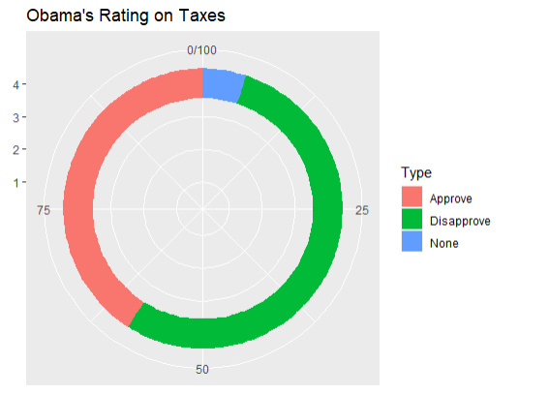

# Python - Bar Chart

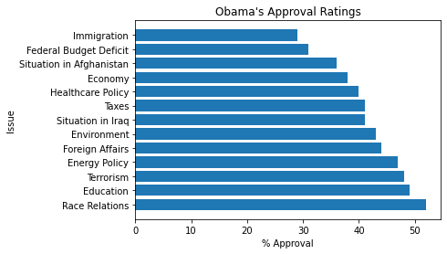

# Python – Stacked Bar Chart

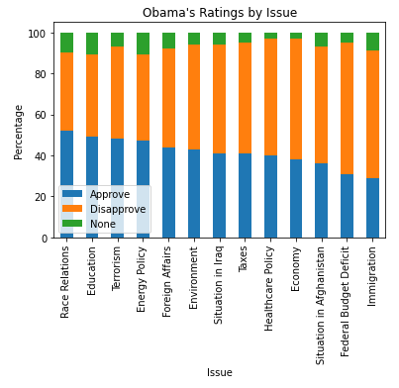

# Python – Pie Chart

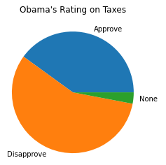

# Python – Donut Chart

